

SOFTWARE DEVELOPMENT

COMP40053

ASSIGNMENT 2

Student Name: David Ayelagbe

Student ID: 25019606

Submission Date: 13th May 2026

Vehicle
# make: String
# model: String
# year: int
# reg: String
# licence: String

+Vehicle(make: String, model: String, year: int, reg: String, Licence: String)
+getMake(): String
+getModel(): String
+getYear(): int
+getReg(): String
+getLicence(): String
+setLicence(licence: String): void
+ isAvailable(): boolean
+toString(): String
+calculateRental(days: int): double

0..*
0..*
CherryCars
-Vehicles: ArrayList<Vehicle>
+ CherryCars()
+addVehicle(vehicle: Vehicle): boolean
+findVehicle(reg: String): Vehicle
+getVehicles(): ArrayList<Vehicle>
+getAvailableByMake(make: String):
ArrayList<Vehicle>
+ rentVehicle(reg:String, customer: Customer): boolean
+returnVehicle(reg: String, customer : Customer): boolean
+CalculateCost(reg: String, days: int): double

Electric
-milesPerCharge: int
+Electric(make: String, model: String, year: int, reg: String, numDoors: int, licence: String, milesPerCharge: int)
+getMilesPerCharge(): int
+toString(): String
+calculateRental(days: int): double

Motorbike
- sidecar: Boolean
+Motorbike(make: String, model: String, year: int, reg: String, licence: String, sidecar: Boolean)
+ isSidecar(): boolean
+toString(): String
+calculateRental(days: int): double

NonElectric
-fuelType: String
+NonElectric(make: String, model: String, year: int, licence: String, reg: String, numDoors: int, fuelType: String)
+getFuelType(): String
+toString(): String
+calculateRental(days: int): double

Customer
- licence : String
- currentRentals : ArrayList<Vehicle>
- previousRentals: ArrayList<Vehicle>

+ Customer(licence: String)
+ getLicence(): String
+ getCurrentRentals(): ArrayList<Vehicle>
+ getPreviousRentals(): ArrayList<Vehicle>
+ hireVehicle(vehicle: Vehicle) : void
+ returnVehicle(vehicle: Vehicle) : void
Car
# numDoors: int
+Car(make: String, model: String, year: int, reg: String, licence: String, numDoors: int)
+getNumDoors(): int
+toString(): String
+calculateRental(days: int): double

TASK 2: TEST PLAN
ELECTRIC

@Before

Test for calculateRental
Test | tesla.calculateRental(20),0.01);
Reason | To know and check Electric calculates rental accordingly and correctly using the number of days and price per day ( £120 )
Expected | 20 * 120  = £2400.0 due to double
Actual | 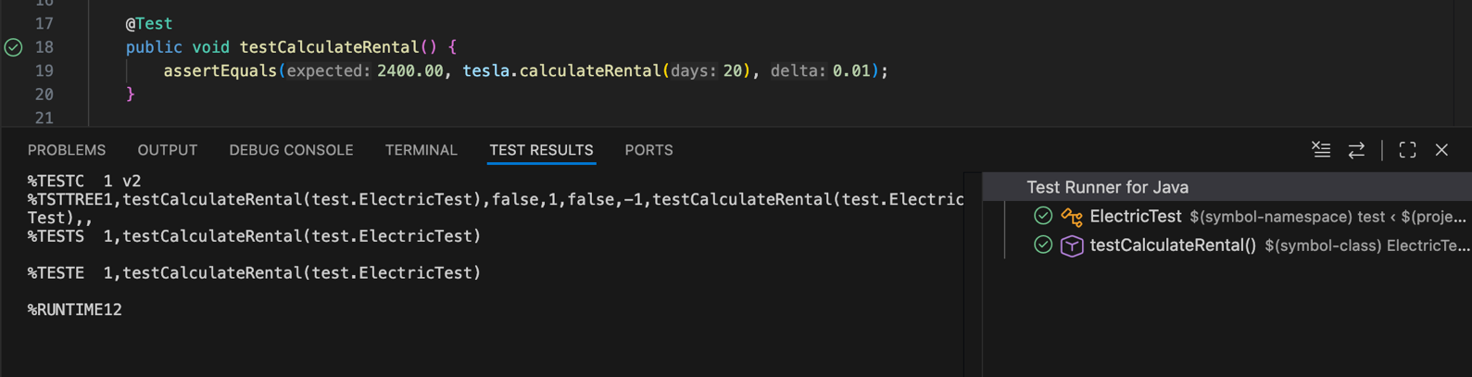
 | PASS

Test for getMilesPerCharge
Test | tesla.getMilesPerCharge();
Reason | To verify that the miles per charge value for electric is stored and returned correctly.
Expected | Miles for the vehicle is 20
Actual | 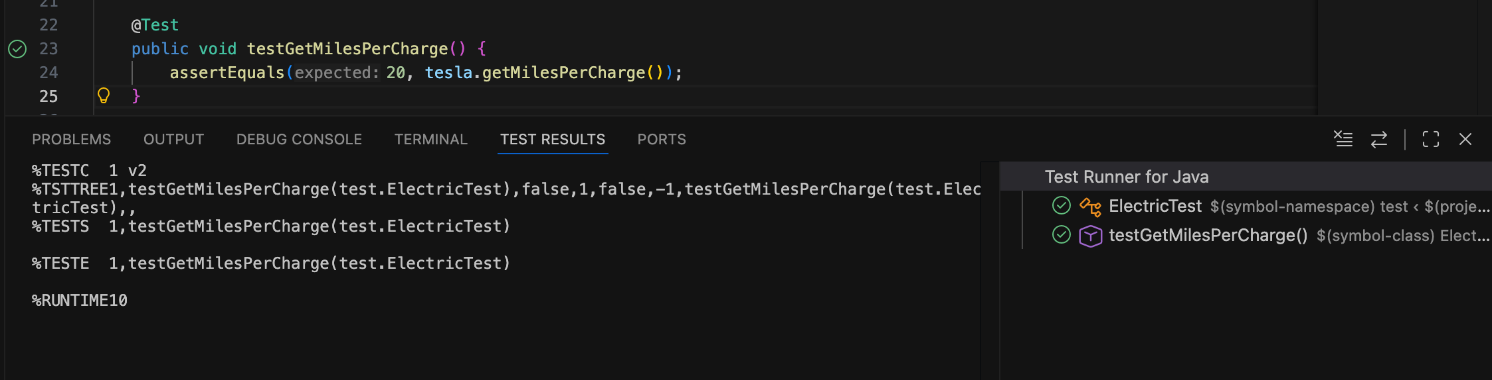
 | PASS

Test for toString
Test | tesla.toString();
Reason | To show Electric details are displayed accurately to the user.
Expected | Available: make=Tesla, model=modelY, year=2026, reg=DD22 DDD, licence= , numDoors=5 , milesPerCharge=20
Actual | 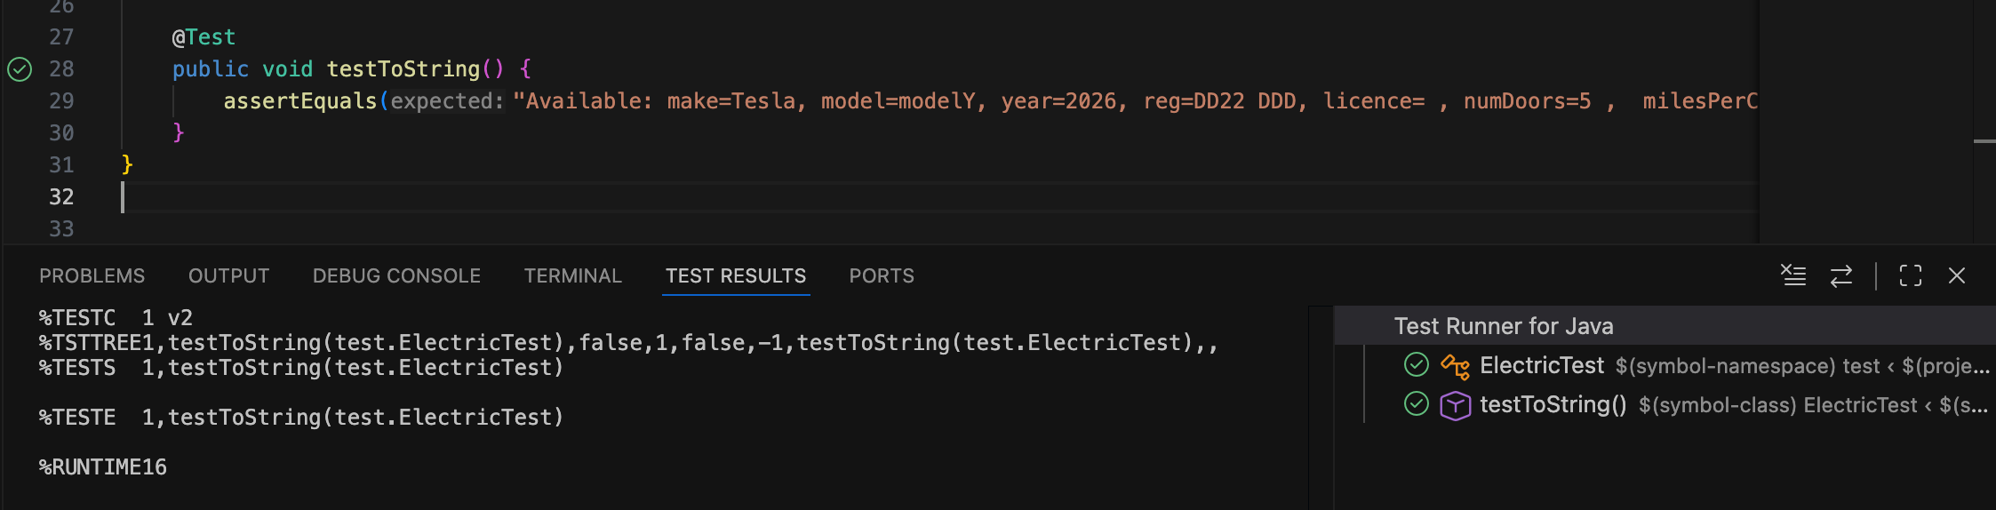
 | PASS

MOTORBIKE
@Before

Test for calculateRental
Test | kawasaki.calculateRental(10),0.01);
Reason | To know and check Motorbike calculates rental accordingly and correctly using the number of days and price per day ( £150 )
Expected | 10 * 150  = £1500.0 due to double
Actual | 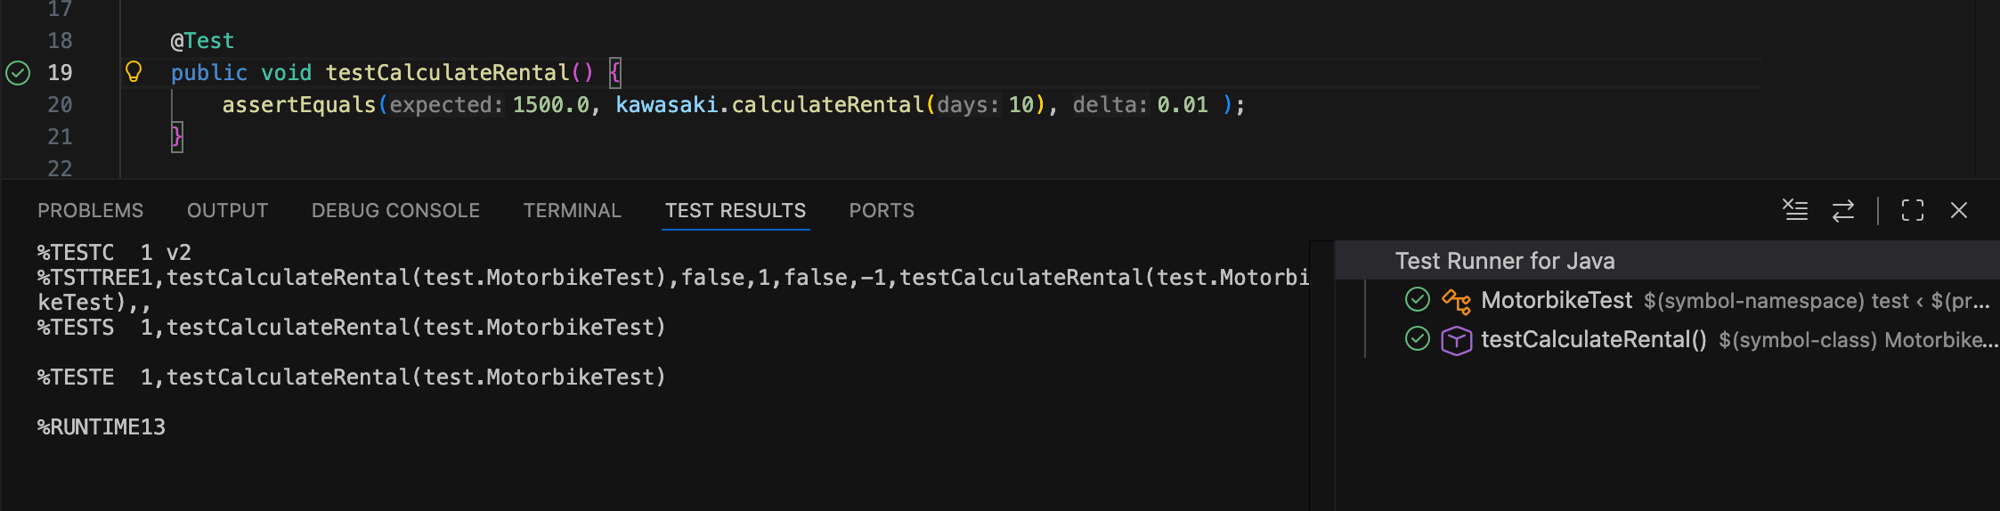
 | PASS

Test for isSidecar
Test | kawasaki.isSidecar();
Reason | To know and check whether Motorbike has side car or not.
Expected | false
Actual | 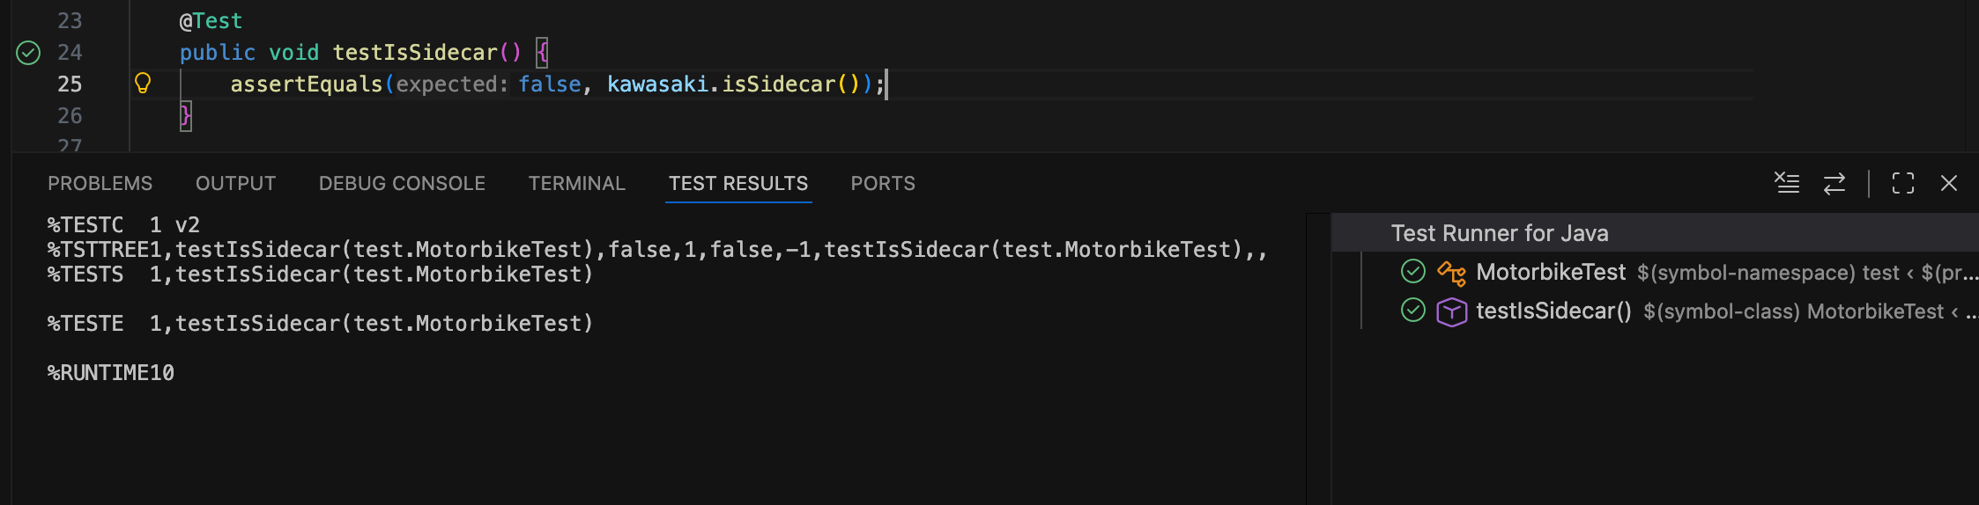
 | PASS

Test for toString
Test | kawasaki.toString();
Reason | To show motorbike displays correctly
Expected | Available: make=Kawasaki, model=K1, year=2026, reg=EE44 EEE, licence=, sidecar=false
Actual | 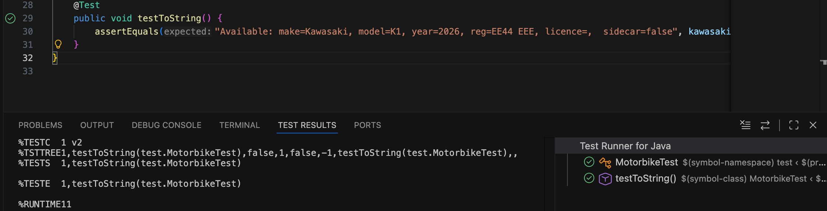
 | PASS

TEST FOR CHERRYCARS
@Before
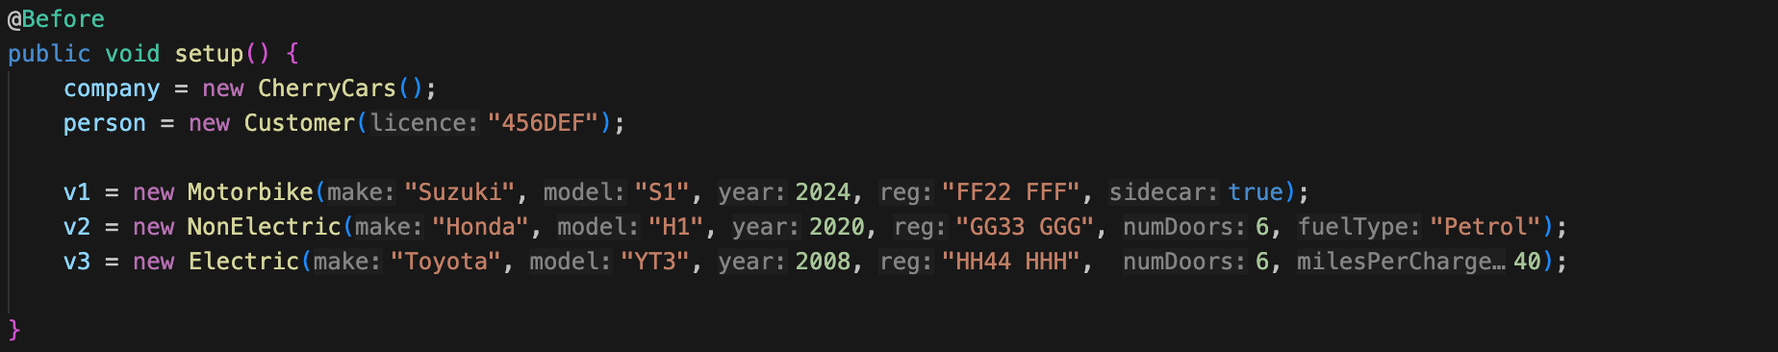

Test for getAvailableByMake
Test | company.addVehicle(v1);  company.addVehicle(v2);  company.addVehicle(v3);  assertEquals(1, company.getVehicleByMake("Suzuki").size());
Reason | To show that choices match exactly with the corresponding make
Expected | Add vehicle 1, successfully  Add vehicle 2, successfully  Add vehicle 3, successfully  Expected 1 and provides vehicle 1 - Suzuki
Actual | 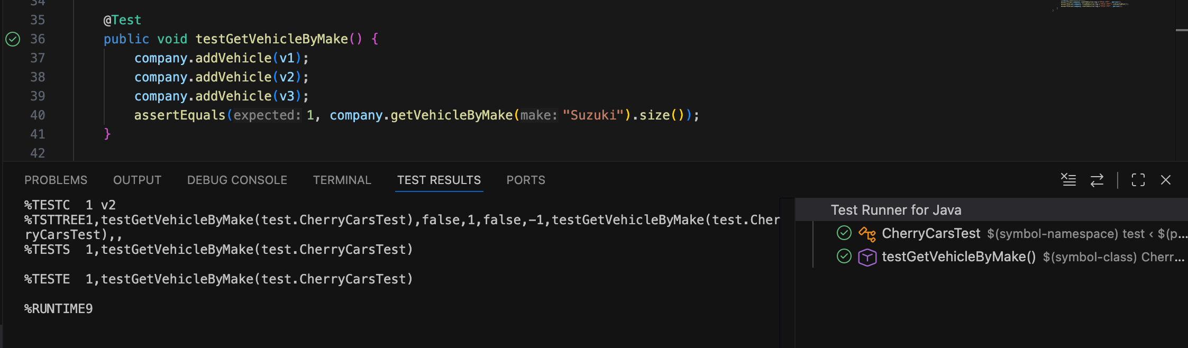
 | PASS

Test for returnVehicle
Test | company.addVehicle(v2);  assertFalse(company.returnVehicle("GG33 GGG", person));  company.rentVehicle("GG33 GGG", person);  assertTrue(company.returnVehicle("GG33 GGG", person));  assertFalse(company.returnVehicle("HH33 HHH", person));
Reason | Ensure you can add vehicle, check invalid return, able to rent the vehicle and then return successfully.
Expected | Add vehicle 2,  Return vehicle failed  then rent it,  return vehicle and should be successful,  return a non-existing vehicle and should fail.
Actual | 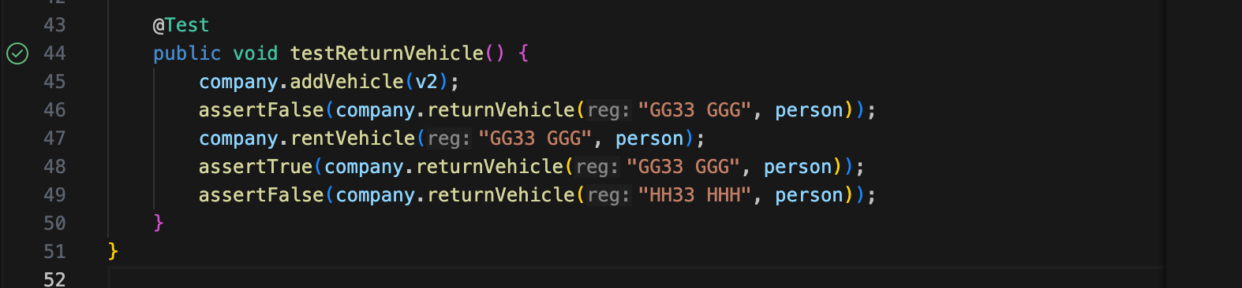
 | PASS

INTERFCAE TEST FOR APP.JAVA

Test for Menu
Test | Run App.java to display Menu
Reason | To show it works fine.
Expected | To show Menu 1-7 for options and -1 to exit.
Actual | 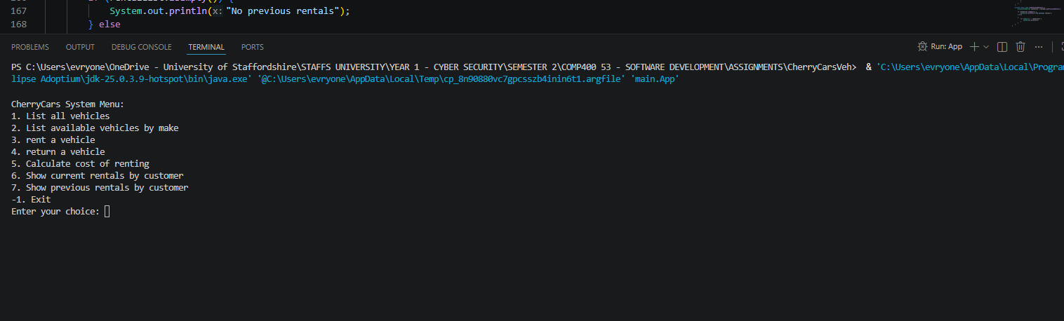
 | PASS

RENT VEHICLE

Test for rentVehicle
Test | Run App.java to display Menu and select option 3 to rent vehicle.
Reason | To test if we can rent vehicle.
Expected | To find vehicle, enter the registration number, and rent it successfully, and when re-renting that same reg number it should be unsuccessful as it’s been rented
Actual | 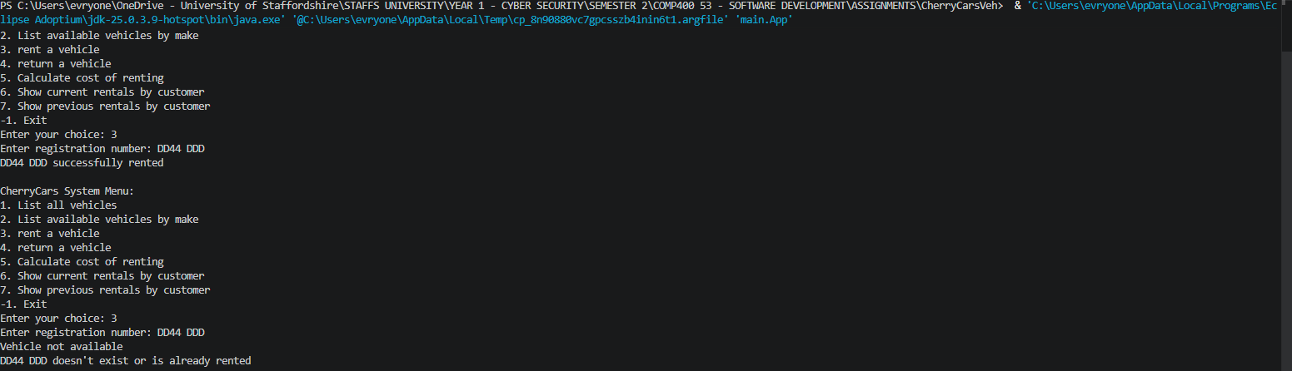
 | PASS

